**Empirical Rate of Equations of Nth Order**

Goal: determining reaction rates depends on rate models --> integration to fit models to data.

-rA = -dCA/dt = kCAn

How many variables in rate equation?

If two, separate variables

∫CA0CA -dCA/CAn = ∫0t kdt

1/(n+1) CA1-n|CA0CA= kt = CA1-n - CA01-n / (n-1) (assuming n ≠ 1)

∫ - CA-n dCA = ∫ kdt

If n = 1, -dCA/dt = kCA

If n ≠ 1, CA1-n - CA01-n = (n-1)kt

How long does it take for reaction to complete?

n > 1 --> CA-->0, t -->∞

n < 1 --> CA = 0, t ≥ CA01-n/(1-n)k

Trial and error solution: select values for k, n

Value of n which minimizes variation in k is the reaction order

Zero order: only in certain concentration ranges

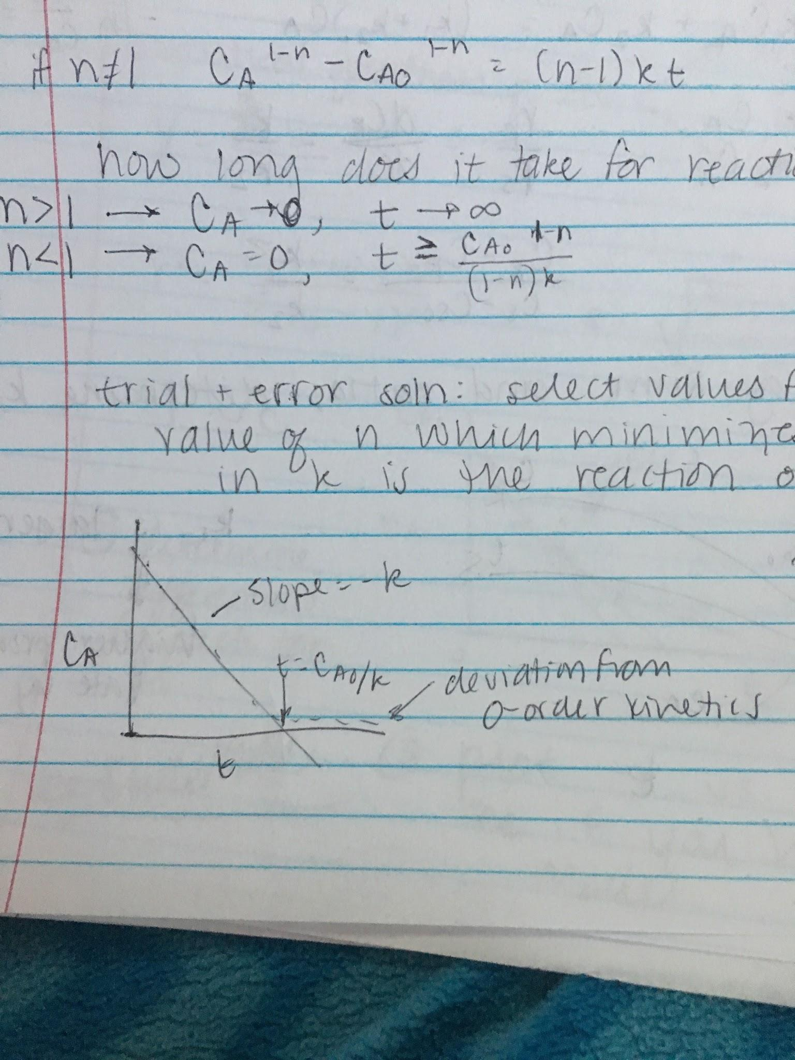

-dCA/dt = k

Conversion proportional to time

CA0 - CA = kt

CA0XA = kt

For t < CA0/k

CA = 0 for t ≥ CA0/k

**Parallel Reactions**

A -->k1 R

A -->k2 S

Three components

-rA = rR

-rA = rS

-rA = k1CA + k2CA = (k1 + k2)CA

-ln(CA0/CA) = (k1 + k2)t

rR = k1CA

rS = k2CA

rR/rS = dCR/dCS = k1/k2

(CR - CR0)/(CS-CS0) = k1/k2

Knowing sum and ratio, determine k1 and k2

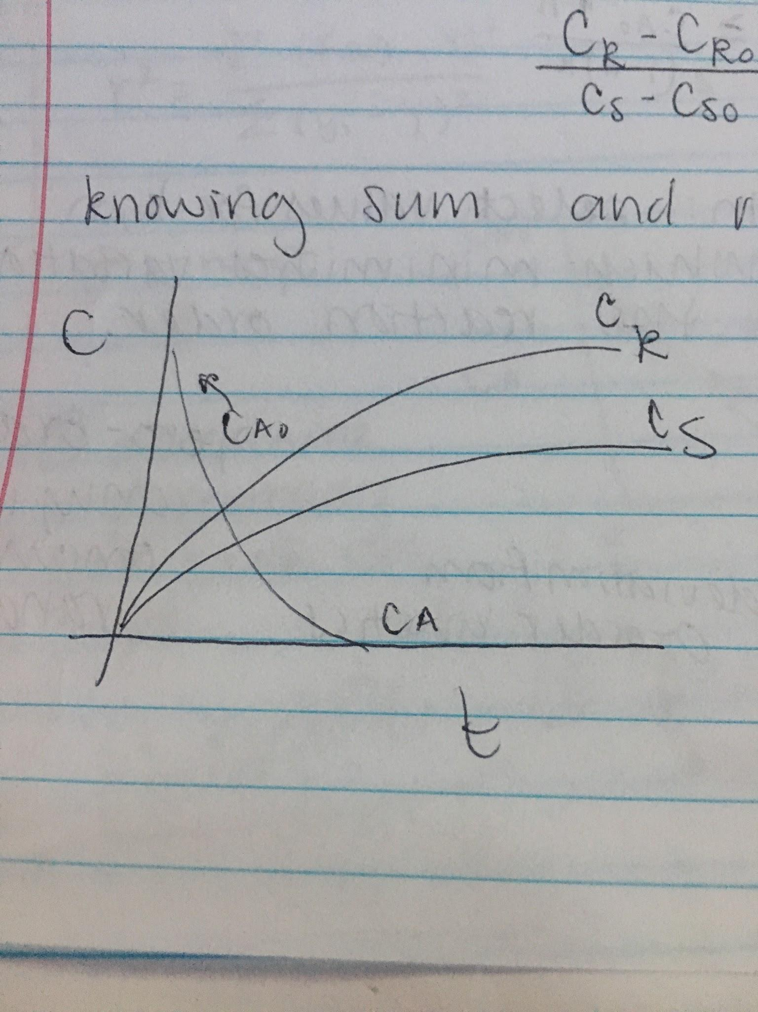

K1 is larger (higher production rate by the end)

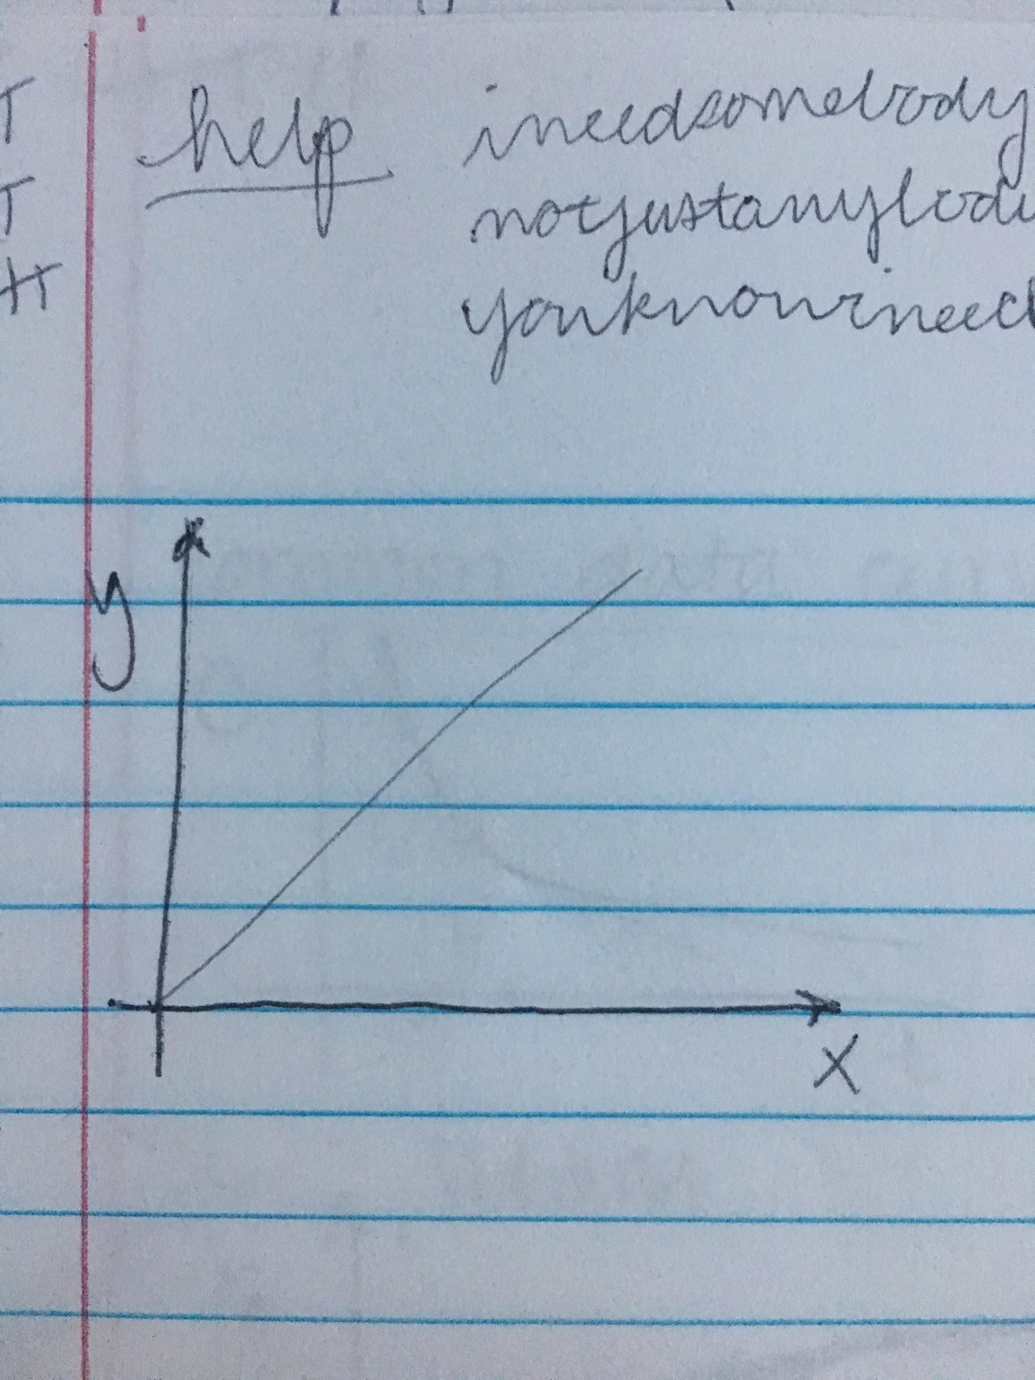

Regression: simplest form: f(x) = ax + b

Generalized polynomial regression model: f(x) = a0 + a1x1 + a2x2 + ... anxn

Hopefully, it will fit with given set of data

∫ -dC/f(c) = kt

Much easier to do differential method with more unknowns

Statistical goodness of fit

Correlation coefficient (r2 = 1)

Standard deviation = 0

Y = m * yi / m

R2 = Σ(f(x) - Y)2 / Σ(yi - Y)2

S = (Σ(f(x) - Y)2/(m-2))1/2

-r ~ c

1. Smooth curve fitting
2. Determine differentials for each tangent point
3. Plot -r vs. c to see if you have linearized model

